**Table of Contents**

**Abstract**

**Introduction**

Objectives

**The experimental site**

Production of snow

**Methods and Data**

Measured snow volume and mass balance

**SNOWPACK Model** Model Results

**Discussion**

**Conclusion**

The surface energy balance

**References**

**Abstract**

In order to optimise the growth of the ice formation throughout the winter, and understand its melt in the spring and summer, it is crucial to understand how various environmental parameters influence the freeze and melt dynamics. I have created a data analysis and modelling pipeline to elucidate the effect of the different parameters measured by the Bloomsky weather station: temperature, UV index, relative humidity, atmospheric pressure. Using machine learning algorithms, I have matched these parameters to changes in the height of the stupa, measured from images snapped by the same weather station (height was manually measured in pixels from the images by Surya, and I extrapolated the pixel dimension to a metric one based on a few reference frames). The data cleaning and processing models used are located here. Unfortunately, the results suffer from a very low sample size in the measurements, and a data deficit at the most important phase of growth and melt especially due to irregular water supply and unavailability of fountain water discharge data.

**Introduction**

Objectives

* Correlating mass loss with the measured surface energy balance
* Comparison of the observed mass and volume evolution with SNOWPACK snow cover model.

**The experimental site**

Baby%20Glacier%20map.pdf

Observations of snow pack located near the Diavolezza glacier is presented. The site’s altitude was 2896 a.s.l. at the base of the glacier. A large snow pile was formed by machine made snow produced during the winter months. The snow pile also contained relatively small amounts of natural snow resulting from precipitation events during winter. In spring this pile was smoothed with an area of around 33 sq.m.(6m\*5.5m) and height of 6m and its evolution was observed from 4th April to 6th September.

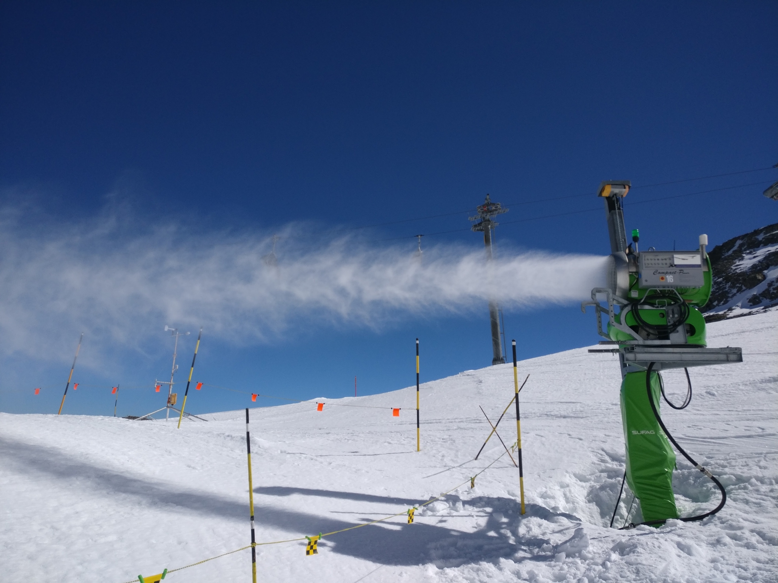

The meteorological conditions for which snow can be produced depend on the type of snow machine used. Wet bulb temperature and wind speed are the most decisive factors. This requires water at high pressure with a sufficiently low (< 2 °C) temperature. The snow machine blows small droplets with an ice nucleus into the air. Due to the freezing of the droplets, the air is heated, and therefore a wind speed of at least 0.5 m/s is required to evacuate the heated air. Once snow has been deposited, it may start to melt, depending on the energy budget of the surface.

**Methods and data**

**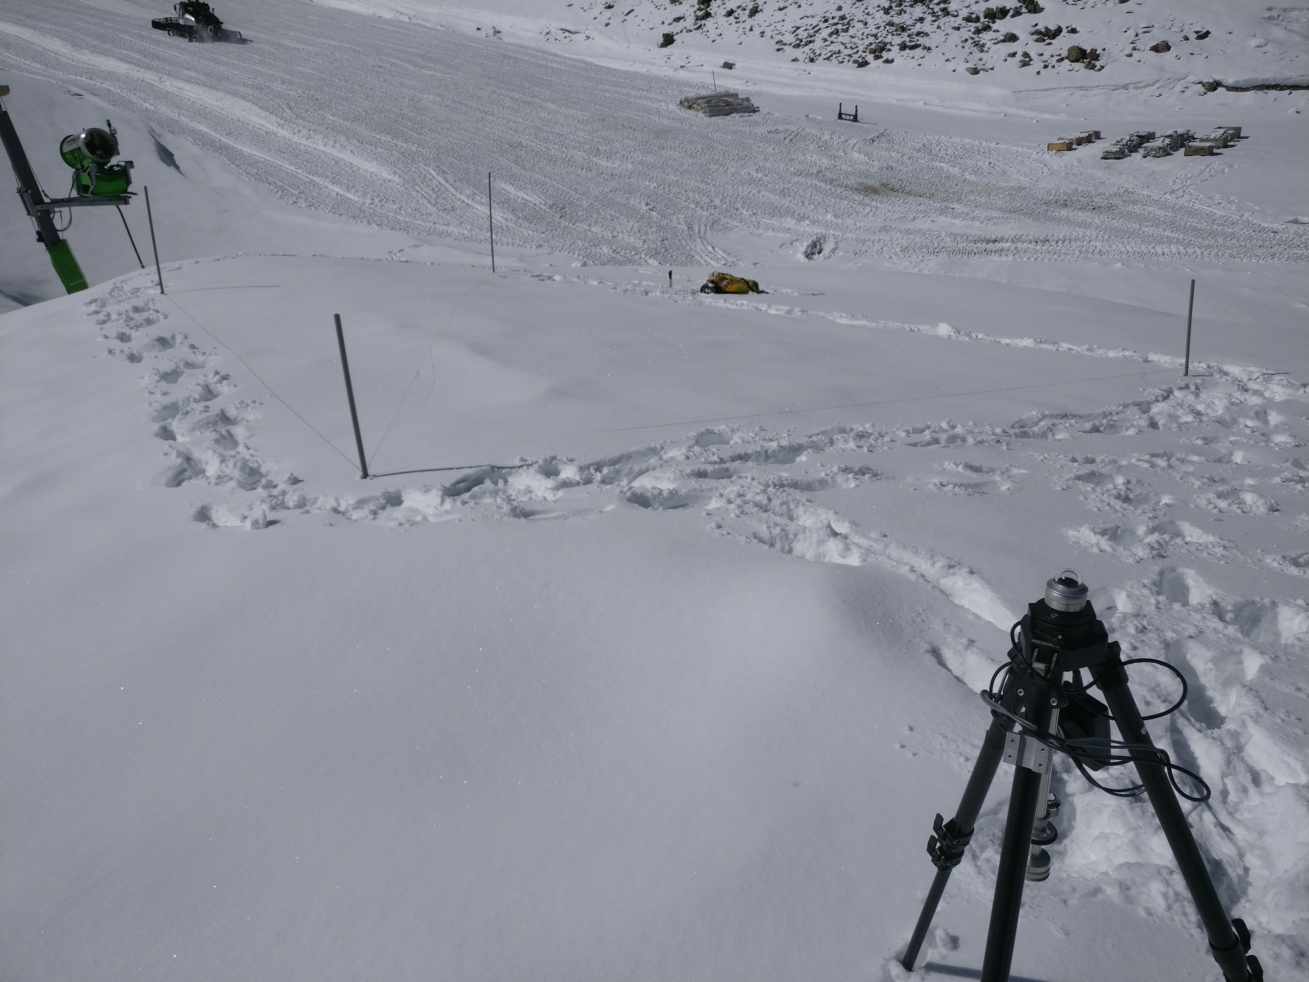**

Weekly measurements were performed of the snow pile’s temperature profile, density, albedo and height. Typically, a 1m snow pit was dug to collect this data. Albedo was measured using an albedometer by noting the mean of max and min values of the current hour. The height of the snow pile was found using four 6m stakes that were steam drilled initially.

Meteorological data was also collected through Utretcht University’s Automatic Weather Station situated a few metres away from the snow pile. Measured meteorological parameters are temperature, humidity, wind speed and direction, incoming and reflected solar radiation, incoming and emitted terrestrial radiation. All these parameters have been stored as 30-min average values.

AWS Weather Data was augmented with the precipitation data from Samedan Airport. This data was quality checked and converted into SMET format with the metadata of the AWS altitude and location.

Measured Snow-height of the snow pile are presented below. The snow pile started with a maximal height of 6m on April 4th and decreased to 1m by 26th September.

**Analysis/figures/HS.pdf**

Results indicate that 19% of the snow volume remained over the summer(24th April-26th Sept)

It needs to be considered that volume loss are not only attributed to snow ablation but also to densification of the snow by settling. Snow densified to 700 kg/m3 by September. Approximately 23100 kg of snow mass remained from 99000 kg, i.e. approx. 4.7% of the snow mass remained over those 6 months.

**SNOWPACK Model**

SNOWPACK is a one-dimensional physically based snow model which has been developed to simulate state and evolution of the snow cover. The multi-layer model rests upon a detailed description of the energy and mass fluxes within the snow and between snow, atmosphere and soil. For this publication SNOWPACK was applied to simulate the evolution of the two snow heaps during a complete summer season. Aims were to identify the dominant processes related to surface energy balance.

SNOWPACK is initialized with a snow profile, describing the state of the snow at the beginning of the simulation. With the one-dimensional SNOWPACK model, we chose to simulate ablation at the top of the snowpile. Corresponding to the maximal HS measured at the snowpile, HS was set to 6 m with a density of 553kg/m3.  These values are typical for settled machine made snow and are based on the measurements described earlier. Snow grain size, Volume fraction of Water, Volume fraction of Void, Specific Heat Capacity and thermal conductivity was set as default.

SNOWPACK is driven by the meteorological measurements Air temperature(TA), Relative Humidity(RH), Ground Temperature(TSG), Snow Surface Temperature(TSS), Height of Snow(HS), Wind velocity(VW&DW), Net Shortwave radiation(OSWR&ISWR), Net Longwave radiation(ILWR&OLWR), Snow Density(RHO\_HN), Snow temperature at 0.25m depth(TS1). These parameters were obtained from Diavolezza automatic weather stations as described earlier. Notably Precipitation data was not used as its phase could not be determined accurately.

All input data were filtered, quality checked and resampled to 30 min time steps using the meteorological input-output library MeteoIO. The modeling time step was set to 60 min. Model outputs are time series of snow profiles and fluxes reflecting the state of the snow pack at different points of time. In context of this study, snow mass, density, water

content and the respective energy and mass fluxes are the parameters of interest.

Hourly meteorological measurements of VW and TA obtained by the Diavolezza station was analyzed for the period 4th April to 6th September 2017. Meteorological input data as applied for the simulations are presented below. Note that the data were aggregated to daily values for the plot while hourly values were used as input for the simulations. Mean temperatures of the survey period was 3.41°C . The mean of VW at Diavolezza was 2.08 m/s. Precipitation cumulated to 484.4 mm. Net shortwave radiation summed to 120.86 kJ/m2 and longwave radiation was calculated -36.07 kJ/m2

**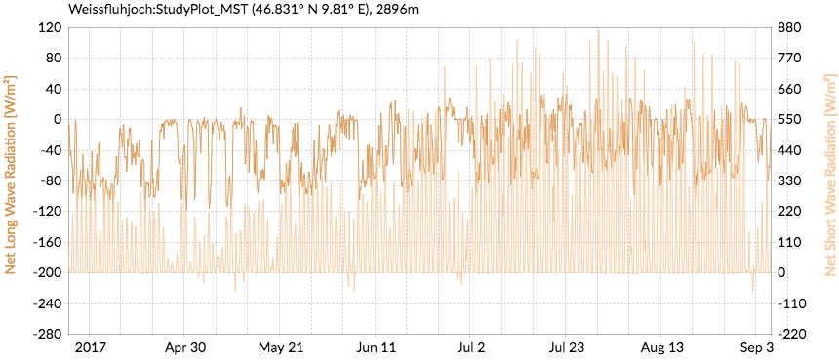**

**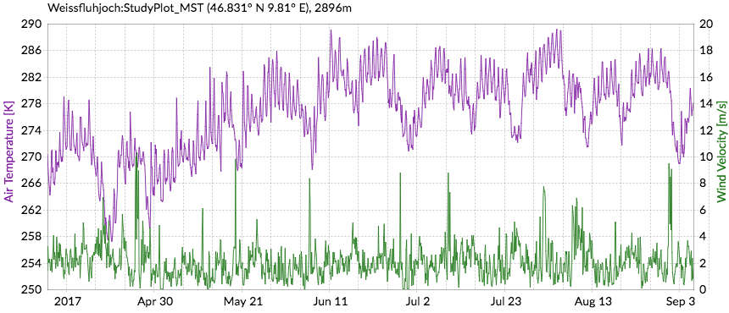**

**Model results**

**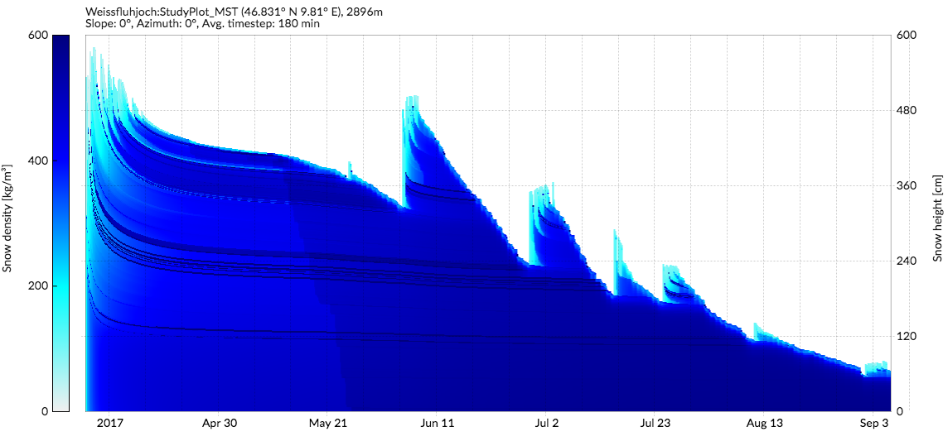**

The figure above shows densification. It is well illustrated how snow is compacted from top to bottom and in the course of time. But the variation in density across the snow pile is not captured well by the model. For example, density at 21 May ranged from 360 at the top to 570 kg/m3 at the bottom of the profile.

**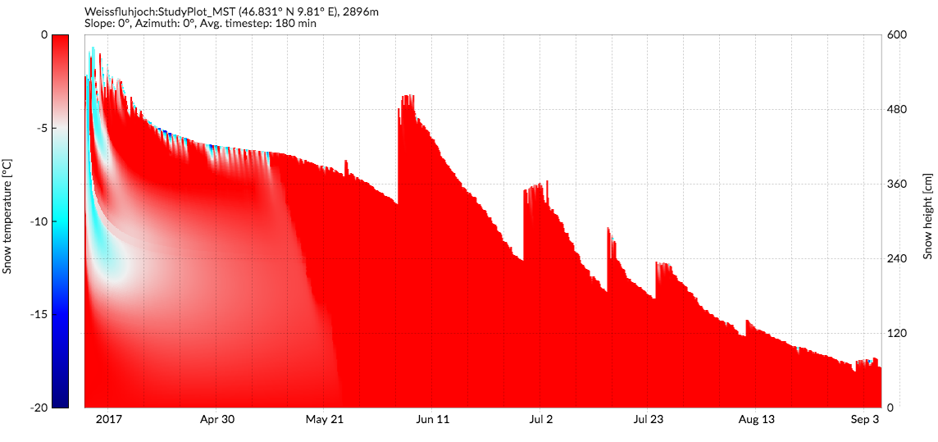**

The temperature profile agree with the manual measurements as they did not deviate much beyond 0C after the initial 10cm of the profile.

**Analysis/figures/energy.pdf**

The Energy Balance clearly correlates with the snow water equivalent. The negative peaks are actually erroneous values as one of the sensors malfunctioned. As the snow profile was already close to 0 C, all the surface energy went into melting the snow. Also the rate of melting is highest in the month of June. Two visits to the site were carried out this month on 7th and 20th. As seen below, the surrounding terrain was snow covered on the 7th and snow free on the 20th. There are two reasons for this. The primary one is the increase in the net short wave radiation as shown below. But also this was the period when the fleece cover was put on the Diavolezza glacier. So all the snow was collected and deposited on the glacier between the 7th to the 20th of June.

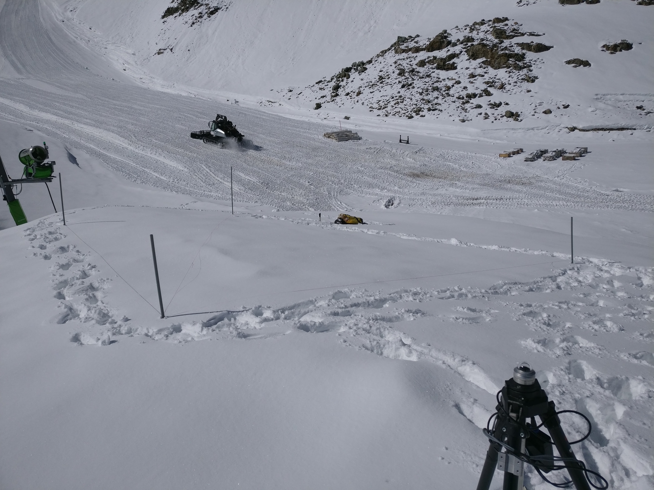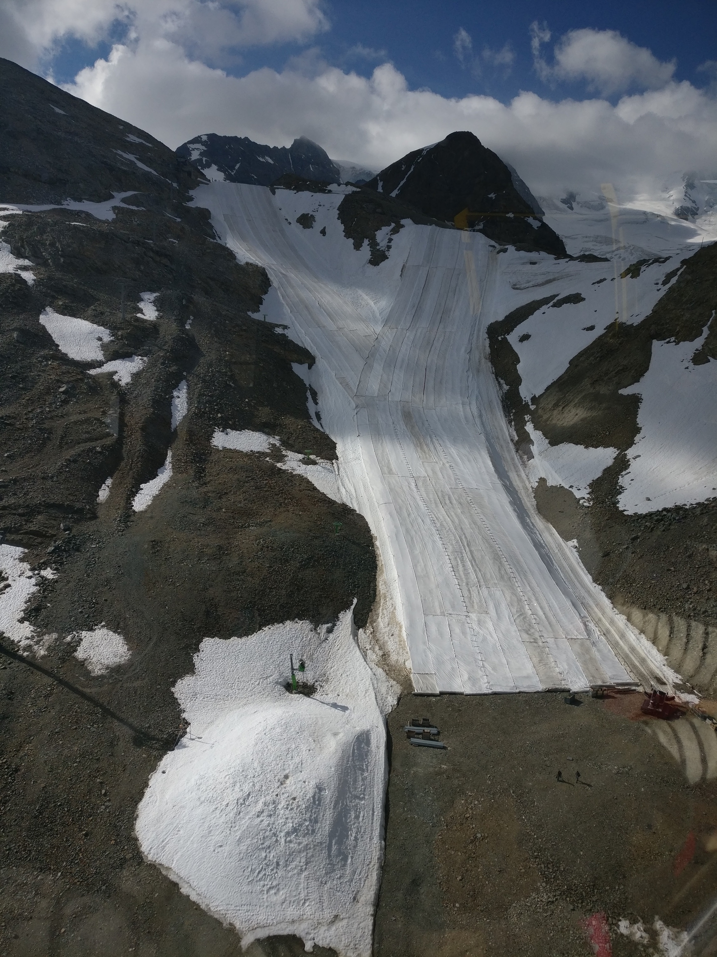

Figure Snow covered terrain on 7th June. Snow tractor collecting the snow can be seen in the background.

Figure Snow free terrain on the 20th of June

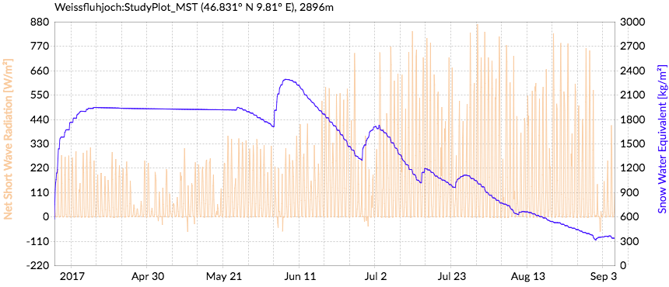

Analysis/figures/albedo.pdf

The modelled albedo values represent average values of every 3 hours and the measured ones represent average values of an hour. Depending on cloud conditions, albedo can vary a lot within an hour. For example, on 30th May measured values varied from 0.77 to 0.83. Modelled albedo corresponded well to some measured values but there were large variations in some. This could be either due to the quality of the artificial snow or the dust that settled on the snow pile surface which was not accounted for. Particularly after the month of June as the surrounding terrain was snow free, a large deviation is seen in the modelled and observed values.

**Discussion**

The Snow pile was not of uniform height across its area when the measurements started and henceit is not meaningful to relate model results calculated for a single point to volume changes for the entire snow pile. Unfortunately, the snow machine used had no logging capability so the influence of precipitation and artificial snow on the snow pack’s evolution could not be separated. More importantly, precipitation as rain is not accounted for which could potentially change the energy balance significantly. Another source of potential error is the assumption of a uniform ground temperature of -0.1 C.  When analyzing SWE instead of HS or volume, uncertainty in snow density measurements must also be considered. We showed that the range of snow densities was considerable with higher densities near to the ground. Throughout the storage period a load and time dependent densification must be assumed due to creep and wet snow metamorphism. As in spring only densities near to the surface could be measured, an adequate initial density profile with an expectable increase with depth could not be captured. This limits the capability to assess the temporal evolution of densification based on measurement but also from the simulation results as the initial snow profile had to be defined with a constant density.Also, precipitation events have been neglected. To give an overview this was the precipitation trend during the experiment:

Analysis/figures/Prec_events.pdf

**Conclusions**

More than 19% of snow volume of a 198 m3 snow pile could be conserved at Diavolezza. Albedo values were consistently lower than expected though. We assume that this reduced performance is attributed to dust settling on the snow surface. Moreover, we applied the physically based snow cover model SNOWPACK to simulate snow ablation at the point scale. A comparison of measurements and simulation results showed good agreement.  Snowpack simulations were also applied to analyze the contribution of the different terms of the energy balance to snow ablation. It could be shown that shortwave radiation was by far the most important source of energy.

